**scenario (edit existing deployment)**

**Pre-requisite**

Let us deploy a nginx deployment with ports

vim deploy.yaml

apiVersion: apps/v1

kind: Deployment

metadata:

name: front-end

spec:

replicas: 3

selector:

matchLabels:

app: nginx

template:

metadata:

labels:

app: nginx

spec:

containers:

- name: nginx

image: nginx:latest

kubectl create -f deploy.yaml

**verify pods are created and running**

kubectl get pods

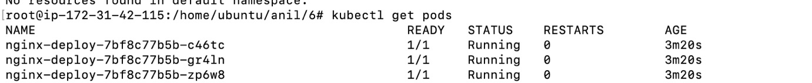

**Task –**

1. Scale the deployment to 4 PODS

Task 1 : solution : Reconfigure the existing deployment front-end and add a port specification named http exposing port 80/tcp of the existing container nginx.

**verify pods are created and running**

kubectl get deploy

kubectl edit deployment front-end



kubectl scale deployment front-end --replicas=4

**verify pods scaled to 4 replicas**

kubectl get deploy && kubectl get pods

====================Lab completion =====================